CSE320 (Data Comm) – Practice Sheet 9: Chapter 12 – CSMA/CD

**S24PA**

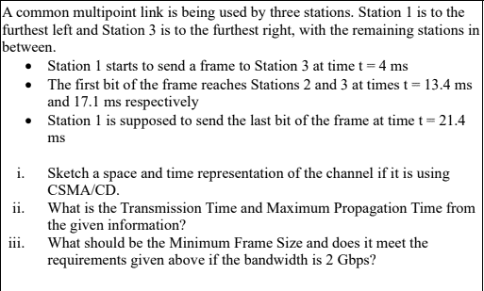

2. Suppose, all the stations are transmitting following CSMA/CD protocol. Station 1 and Station 3 are at opposite ends of the common multipoint link that all the stations share. The bandwidth of the link is 10 Gbps.

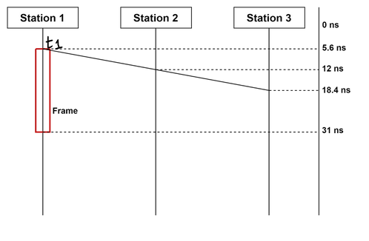

1. **Find** out the transmission time and maximum propagation time from the given diagram.
2. If collision detection methods are introduced, what should be the minimum size of the frame in bytes? Does the frame in the given diagram meet the minimum size requirement?